DBMS Tutorial
A Database Management System (DBMS) is software used to manage data from a database. It acts as an interface between the database and end users or applications, ensuring data is consistently organised, easily accessible, and secure.
- A database is a structured collection of data that is stored in an electronic device. The data can be text, video, image, or any other format.
- A relational database stores data in the form of tables, and a NoSQL database stores data in the form of key-value pairs.
- A DBMS is a software that allows to create, update, and retrieval of data in an organised way. It also provides security to the database.
- Examples of relational DBMS are MySQL, Oracle, Microsoft SQL Server, PostgreSQL, and Snowflake.
- Examples of NoSQL DBMS are MongoDB, Cassandra, DynamoDB, and Redis.
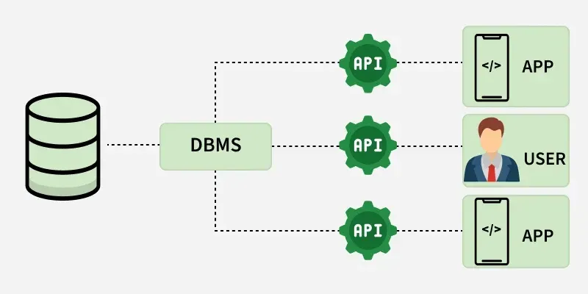

NEED FOR DBMS
A Database Management System (DBMS) is software that allows the storage, organization, and management of large amounts of data. It ensures data consistency, integrity, and security, allowing multiple users to access and manipulate data.
- Organizing and Managing Data: Easy to find and use with features like indexing and fast search.
- Data Security and Privacy: Keeps data safe with login controls, encryption, and strict access rules.
- Better Data Insights: Helps to turn raw data into useful insights, making faster decisions.
- Saves Time and Money: Cuts costs by reducing data duplication and is more efficient than old-school file systems.
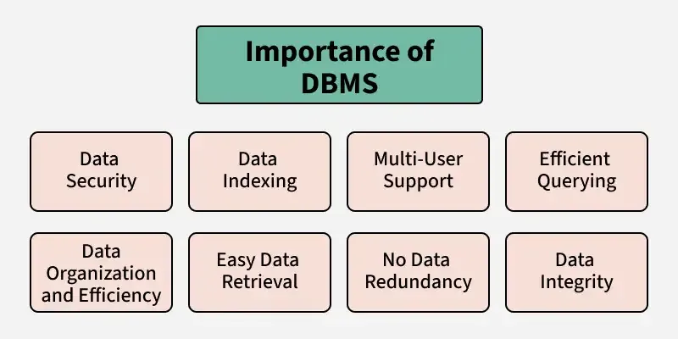
Traditional File Systems
Data is stored and retrieved using files in a typical file system.
- A company keeps separate files for employee details, customer information, and daily sales.
- These files could be stored as text documents, spreadsheets or printed records in cabinets.
- Easy to create and manage files without requiring specialized software.
- No need to invest in additional tools or training to use file systems.
- Users could access files directly from storage devices.
Advantages of DBMS over File Systems
1. Reduced Data Redundancy
- Data is stored in a centralized location, removing unnecessary duplication.
- Example: Customer details are stored in one central database, accessible for all operations.
2. Improved Data Integrity and Consistency
- Changes made in the database are reflected across all related data points.
- Example: If a customer’s address is updated, all orders reflects the new address.
3. Enhanced Security
- DBMS provides role-based access and ensures only authorized users can view or modify the data.
- Example: Only HR staff can access employee salary details.
4. Support for Data Relationships
- Relational DBMS links data points, making relationships easier to manage.
- Example: Customers and their orders can be linked using a “customer ID.”
5. Data Independence
- DBMS provides logical and physical data independence, meaning changes in schema or storage do not affect application programs.
- Example: Index can be created on CustomerID to speed up searches without changing application queries.
6. Query Optimization
- It uses cost-based query optimizers to choose the most efficient execution plan for SQL queries.
- Example: Using CustomerID to quickly find a customer’s orders instead of scanning the entire table.
Role of DBMS
- Managing data efficiently with optimized storage and retrieval.
- Providing simple query languages like SQL.
- Ensuring data consistency and concurrency with transaction controls.
- Enforcing robust security policies with built-in access controls.
File System Applications
File systems store and organize raw files on storage devices without advanced querying or relationship management, making them suitable for simple use cases with low concurrency.
1. Personal Computing
- Used to keep everyday files such as documents, photos, and videos.
- Example: NTFS is used on Windows for personal folders, and ext4 is used on Linux for home directories.
2. Embedded Systems
- Suitable for basic data logging in resource-constrained systems.
- Example: IoT devices or routers storing firmware logs on flash memory without SQL overhead.
3. Content Delivery
- To serve static content such as images and videos.
- Example: NFS for sharing media files across small networked web servers.

INTRODUCTION OF DBMS
DBMS (Database Management System) is a software system that manages, stores, and retrieves data efficiently in a structured format. DBMS acts as a bridge between a central database and multiple clients, including apps and users.
- A DBMS connects the central database with multiple clients (applications and users).
- It allows users to create, update, and query databases efficiently.
- Ensures data integrity, consistency, and security across multiple users and applications.
- Reduces data redundancy and inconsistency through centralized control.
- Supports concurrent data access, transaction management, and automatic backups.
- Uses APIs to handle data requests, ensuring secure and efficient access.

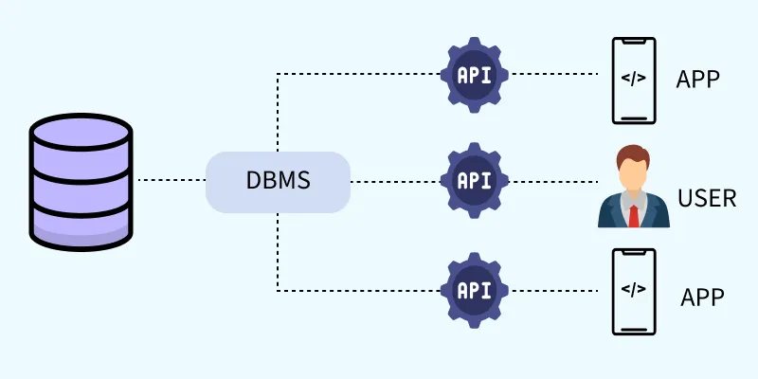
Problems With Traditional File-Based Systems
Before the introduction of modern DBMS, data was managed using basic file systems on hard drives. While this approach allowed users to store, retrieve and update files as needed, it came with numerous challenges
Data Redundancy: Duplicate entries across files
- Inconsistency: Conflicting or outdated information
- Difficult Access: Manual file search required
- Poor Security: No control over data access
- Lack of Multi-user Support: No support for collaboration
- No Backup/Recovery: Data loss was often permanent
- A university file-based system storing data in separate files (e.g., Academics, Results, Hostels) often faced these problems.

Components of DBMS Applications
Any DBMS based application is made up of six key components that work together to handle data effectively.
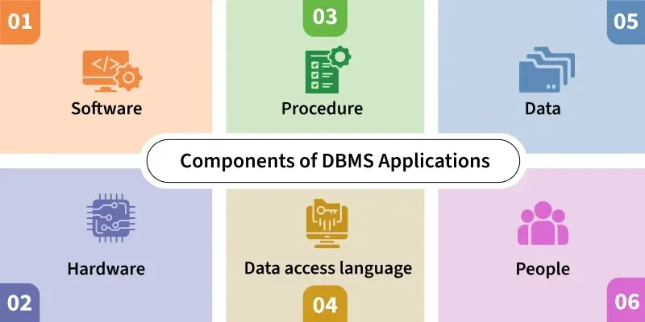

1. Hardware
- Physical devices like servers, disks, input-output devices (keyboard, monitor, printer).
- Stores and processes data; interfaces between real-world inputs and digital systems.
- Examples: Personal computer hard disk, RAM, network devices used for DBMS operations.

2. Software
- Actual DBMS software like MySQL, Oracle, PostgreSQL.
- Includes the database engine, OS, network software, and application tools.
- Translates database access languages into operations.

3. Data
- Raw facts stored in structured or unstructured formats.
- Operational Data: Actual user data (e.g., name, age).
- Metadata: Data about data (e.g., storage time, size, data type).
- Core reason DBMS exists—to manage and store data efficiently.

4. Procedures
- Instructions and rules for using DBMS effectively.
- Covers setup, login/logout, data validation, backup, access control, and report generation.
- Helps ensure consistent and secure use of the system.

5. Database Access Language
- Used to interact with the database (create, read, update, delete data).
- Examples: SQL, MyAccess, Oracle PL/SQL.
- DDL (Data Definition Language) – CREATE, ALTER, DROP
- DML (Data Manipulation Language) – INSERT, UPDATE, DELETE

6. People
- Users interacting with DBMS at different levels:
- Database Administrators (DBA) – Manage security, performance, user access.
- Developers – Build applications using the database.
- End Users – Use applications to access the database (e.g., students, employees).

Types of DBMS
There are several types of Database Management Systems (DBMS), each tailored to different data structures, scalability requirements and application needs. The most common types are as follows:
1. Relational Database Management System (RDBMS)
- It organizes data into tables (relations) composed of rows and columns.
- Uses primary keys to uniquely identify rows and foreign keys to establish relationships between tables.
- Queries are written in SQL (Structured Query Language), which allows for efficient data manipulation and retrieval.
Examples: MySQL, Oracle, Microsoft SQL Server and PostgreSQL.
2. NoSQL DBMS
- They are designed to handle large-scale data and provide high performance for scenarios where relational models might be restrictive.
- They store data in various non-relational formats, such as key-value pairs, documents, graphs or columns.
- These flexible data models enable rapid scaling and are well-suited for unstructured or semi-structured data.
Examples: MongoDB, Cassandra, DynamoDB and Redis.
3. Object-Oriented DBMS (OODBMS)
- It integrates object-oriented programming concepts into the database environment, allowing data to be stored as objects.
- Supports complex data types and relationships, making it ideal for applications requiring advanced data modeling and real-world simulations.
Examples: ObjectDB, db4o.
4. Hierarchical Database
- Organizes data in a tree-like structure, where each record (node) has a single parent and have multiple children.
- This model is similar to a file system with folders and subfolders.
- It is efficient for storing data with a clear hierarchy, such as organizational charts or file directories.
- Navigation is fast and predictable due to the fixed structure.
- It lacks flexibility and is difficult to restructure or handle complex many-to-many relationships.
Example: IBM Information Management System (IMS).
5. Network Database
- It uses a graph-like model to allow more complex relationships between entities.
- Unlike the hierarchical model, it permits each child to have multiple parents, enabling many-to-many relationships.
- Data is represented using records and sets, where sets define the relationships.
- It is more flexible than the hierarchical model and better suited for applications with complex data linkages.
Example: Integrated Data Store (IDS), TurboIMAGE.
6. Cloud-Based Database
- They are hosted on cloud computing platforms like AWS, Azure or Google Cloud.
- They offer on-demand scalability, high availability, automatic backups and remote accessibility.
- These databases can be relational (SQL) or non-relational (NoSQL) and are maintained by cloud service providers, reducing administrative overhead.
- They support modern application requirements, including distributed access and real-time analytics.
Example: Amazon RDS (for SQL), MongoDB Atlas (for NoSQL), Google BigQuery.
Database Languages
Database languages are specialized sets of commands and instructions used to define, manipulate and control data within a database. Each language type plays a distinct role in database management, ensuring efficient storage, retrieval and security of data. The primary database languages include:

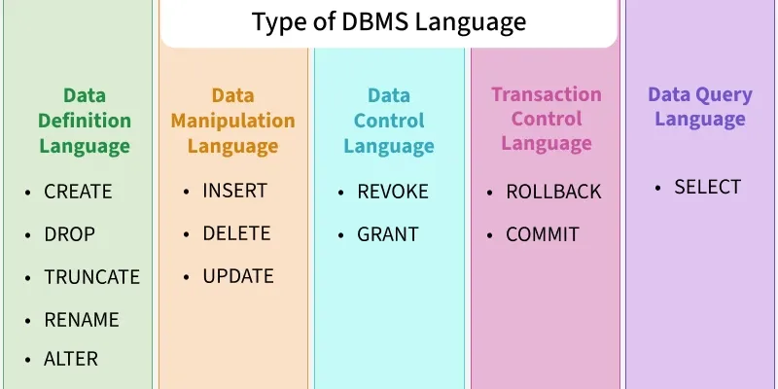
1. Data Definition Language (DDL)
DDL is the short name for Data Definition Language, which deals with database schemas and descriptions, of how the data should reside in the database.
- CREATE: to create a database and its objects like (table, index, views, store procedure, function and triggers)
- ALTER: alters the structure of the existing database
- DROP: delete objects from the database
- TRUNCATE: remove all records from a table, including all spaces allocated for the records are removed
- COMMENT: add comments to the data dictionary
- RENAME: rename an object
2. Data Manipulation Language (DML)
DML focuses on manipulating the data stored in the database, enabling users to retrieve, add, update and delete data.
- INSERT: insert data into a table
- UPDATE: updates existing data within a table
- DELETE: Delete all records from a database table
- MERGE: UPSERT operation (insert or update)
- CALL: call a PL/SQL or Java subprogram
- EXPLAIN PLAN: interpretation of the data access path
- LOCK TABLE: concurrency Control
3. Data Control Language (DCL)
DCL commands manage access permissions, ensuring data security by controlling who can perform certain actions on the database.
- GRANT: Provides specific privileges to a user (e.g., SELECT, INSERT).
- REVOKE: Removes previously granted permissions from a user.
4. Transaction Control Language (TCL)
TCL commands oversee transactional data to maintain consistency, reliability and atomicity.
- ROLLBACK: Undoes changes made during a transaction.
- COMMIT: Saves all changes made during a transaction.
- SAVEPOINT: Sets a point within a transaction to which one can later roll back.
5. Data Query Language (DQL)
DQL is a subset of SQL used to retrieve data from a database without modifying it. Its main command is SELECT, which allows users to fetch specific information based on their requirements.
Applications of DBMS
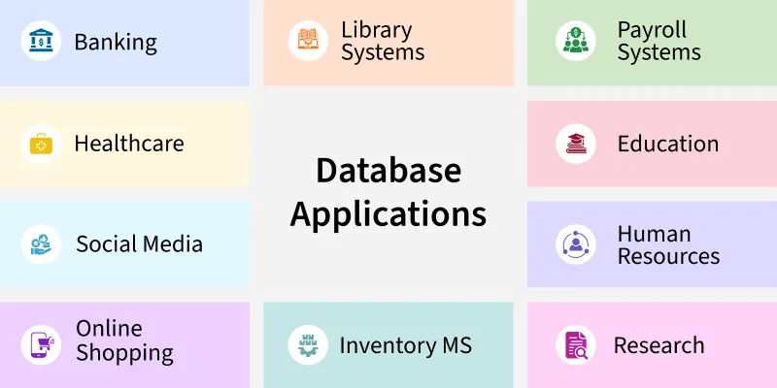
- Banking: Manages accounts and transactions.
- E-commerce: Tracks products, orders, and customers.
- Healthcare: Stores patient records and diagnoses.
- Education: Handles student grades and schedules.
- Social Media: Manages user profiles and interactions.
- Data Science: Supports analytics and predictions.

MYSQL INTRODUCTION
MySQL is an open-source relational database management system (RDBMS) that uses Structured Query Language (SQL) to store, manage, and manipulate data. It is one of the most widely used database systems in web applications because of its speed, reliability, and ease of use.
- Developed and maintained by Oracle Corporation.
- Supports multiple platforms including Windows, Linux, and macOS.
- Commonly used with programming languages like PHP, Java, and Python to build dynamic applications.
- Known for its scalability, strong security features, and large developer community support.
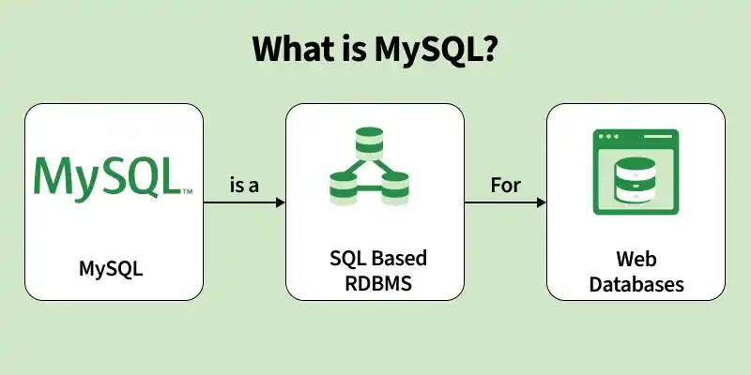
Working of MySQL
MySQL processes client requests and interacts with stored data to execute SQL queries efficiently. It follows a structured workflow to retrieve or modify data while ensuring accuracy and reliability.
- Client Request: A user sends an SQL query to the MySQL server through an application, programming interface, or command-line tool to perform a database operation.
- Connection: The MySQL server establishes a connection with the client application, creating a session that allows queries to be sent and processed.
- SQL Parsing: The server analyzes the SQL query to check for syntax errors and verifies whether the query structure is valid.
- Query Optimization: MySQL evaluates different execution strategies and selects the most efficient way to process the query.
- Execution: The server executes the query to retrieve, insert, update, or delete data from the database.
- Storage Engine: MySQL uses storage engines such as InnoDB or MyISAM to manage how data is stored, retrieved, and maintained on disk.
- Result Generation: After executing the query, the server prepares the requested data or confirmation message as the result.
- Response: The generated result is sent back from the MySQL server to the client application.
- Client Interaction: The application receives the response and displays the results to the user in a readable format.
- Transaction Management: MySQL manages transactions to ensure that multiple operations are executed reliably and maintain data consistency.
- Logging and Recovery: The server records logs that help recover data and restore operations if system failures occur.
- Replication and Backup: MySQL supports data replication across multiple servers and regular backups to improve performance and ensure data safety.
MySQL receives a query, processes it efficiently, interacts with stored data, and returns the results while maintaining data integrity and reliability.
Features in MySQL
MySQL is a popular choice for managing relational databases for several reasons:
- Open-Source: MySQL is free and open-source, allowing modification and distribution.
- High Performance: It offers fast data retrieval and processing for large datasets.
- ACID Compliance: Ensures data integrity and reliability, especially with InnoDB storage.
- Scalability: Supports large databases and high traffic with features like partitioning and clustering.
- Multiple Storage Engines: Offers different storage engines (e.g., InnoDB, MyISAM) for flexible use.
- Replication: Supports master-slave replication for data redundancy and high availability.
- Security Features: Provides user authentication, SSL encryption, and secure data storage options.
Who Uses MySQL
MySQL is a widely-used relational database management system (RDBMS) that caters to various user groups, from small businesses to large enterprises.
- Small and Medium Businesses (SMBs): SMBs use MySQL to manage customer data, transactions, and business records efficiently.
- Large Enterprises: Large companies use MySQL to handle large databases and high-traffic applications.
- Web Developers: Developers use MySQL as a backend database for websites and web applications.
- Educational Institutions: Schools and universities use MySQL for teaching database management and SQL concepts.
Applications of MySQL
MySQL is widely used across different industries due to its reliability, scalability, and performance. It supports various applications that require efficient data storage and management.
- E-commerce: MySQL is used in e-commerce platforms to manage product catalogs, customer information, orders, and transactions.
- Content Management Systems (CMS): Many CMS platforms use MySQL to store website content, user data, comments, and configuration settings.
- Financial Services: MySQL helps manage transactional data, customer accounts, and financial records in banking and payment systems.
- Healthcare: Healthcare applications use MySQL to store and manage patient records, medical histories, and treatment information.
- Social Media: Many social media platforms rely on MySQL to store user profiles, posts, comments, and other interactions.
The Cloud and the Future of MySQL
Cloud technology has significantly influenced the development of MySQL, enabling better scalability, availability, and performance for modern applications.
Cloud Integration
Cloud platforms enable MySQL to run as managed services with easier deployment, scaling, and maintenance.
- Managed Services: Cloud providers such as AWS, Google Cloud, and Microsoft Azure offer managed MySQL services like Amazon RDS and Google Cloud SQL to simplify database management and maintenance.
- Scalability: Cloud environments allow MySQL databases to scale resources dynamically based on application demand.
Enhanced Features
Cloud-based MySQL solutions provide improved reliability, availability, and automated management features.
- High Availability: Cloud-based MySQL solutions provide built-in high availability and disaster recovery options to improve reliability.
- Automatic Backups: Cloud platforms offer automated backup systems that help maintain data safety and simplify recovery.
Future Trends
The future of MySQL includes deeper integration with modern cloud technologies and advanced data systems.
- Hybrid Cloud Deployments: Organizations increasingly combine on-premises databases with cloud environments for better flexibility.
- Advanced Analytics: MySQL is being integrated with cloud analytics and machine learning platforms to enable deeper data insights.
- Serverless Architectures: MySQL may evolve to support serverless environments, making database management more efficient and cost-effective.
MySQL vs SQL
Here are some key differences between MySQL and SQL:
MySQL | SQL
MySQL is a Relational Database Management System (RDBMS) used to store and manage databases. | SQL (Structured Query Language) is a standard language used to communicate with relational databases.
It is database software that implements SQL to manage data. | It is a query language used to create, retrieve, update, and delete data.
MySQL is open-source and freely available. | SQL is a standard language, not a software product.
It supports basic programming languages like C, C++, Python, Ruby, etc. | SQL is used within database systems like MySQL, PostgreSQL, SQL Server, and Oracle.
MySQL is used to store, manage, and organize data in databases. | SQL is used to write queries to interact with those databases.

MYSQL DATE DATA TYPE
MySQL DATE Data Type stores date values in the format 'YYYY-MM-DD' and has a valid range of values from '1000-01-01' to '9999-12-31'.
DATE Data Type in MySQL
The Data data type in MySQL is used to store date values in a column. During later data analysis, it is necessary to perform date-time operations on the data.
Dates are displayed in the format 'YYYY-MM-DD', but can be inserted using either strings or numbers. If any invalid date is inserted, MySQL will store '0000-00-00' by default.
Syntax
DATE Data Type Syntax is:
Variable_Name DATE
MySQL DATE Data Type Examples
The following examples will illustrate how we can use Date data type in MySQL in a variable.
Creating a table with DATE Data Type Column Example
In this example, we will create a table 'StudentDetails'. The table consists of Student_Id, First_name, Last_name, Date_Of_Birth, Class, Contact_Details columns. Among these the data type of Date_Of_Birth column is DATE.
Query:
CREATE TABLE StudentDetails (
Student_Id INT AUTO_INCREMENT,
First_name VARCHAR (100) NOT NULL,
Last_name VARCHAR (100) NOT NULL,
Date_Of_Birth DATE NOT NULL,
Class VARCHAR (10) NOT NULL,
Contact_Details BIGINT NOT NULL,
PRIMARY KEY(Student_Id )
);
Inserting Date into DATE Data Type Column Example
In this example, we will insert data into table. We will also insert date in the Date_Of_Birth column as its data type is Date.
Query:
INSERT INTO
StudentDetails(First_name , Last_name , Date_Of_Birth , Class, Contact_Details)
VALUES
('Amit', 'Jana', '2004-12-22', 'XI', 1234567890),
('Manik', 'Aggarwal', '2006-07-04', 'IX', 1245678998),
('Nitin', 'Das', '2005-03-14', 'X', 2245664909),
('Priya', 'Pal', '2007-07-24', 'VIII', 3245642199),
('Biswanath', 'Sharma', '2005-11-11', 'X', 2456789761),
('Mani', 'Punia', '2006-01-20', 'IX', 3245675421),
('Pritam', 'Patel', '2008-01-04', 'VII', 3453415421),
('Sayak', 'Sharma', '2007-05-10', 'VIII' , 1214657890);
To verify using the following command as follows.
SELECT * FROM StudentDetails ;
Output :
Student_Id | First_name | Last_name | Date_Of_Birth | Class | Contact_Details
1 | Amit | Jana | 2004-12-22 | XI | 1234567890
2 | Manik | Aggarwal | 2006-07-04 | IX | 1245678998
3 | Nitin | Das | 2005-03-14 | X | 2245664909
4 | Priya | Pal | 2007-07-24 | VIII | 3245642199
5 | Biswanath | Sharma | 2005-11-11 | X | 2456789761
6 | Mani | Punia | 2006-01-20 | IX | 3245675421
7 | Pritam | Patel | 2008-01-04 | VII | 3453415421
8 | Sayak | Sharma | 2007-05-10 | VIII | 1214657890
So, we have successfully stored the DATE data-type in the Date_Of_Birth Column.
Similary we can create another table 'ProductDetails'
It consists of ProductId, ProductName, and Manufactured_On columns, among which the data type for Manufactured_On columns is DATE.
Query:
CREATE TABLE ProductDetails(
ProductId INT NOT NULL,
ProductName VARCHAR(20) NOT NULL,
Manufactured_On DATE NOT NULL,
PRIMARY KEY(ProductId)
);
Inserting data into the Table -
The CURRENTDATE function is used to assign value in the Manufactured_On column. The return data type for CURRENTDATE function is DATE.
Query:
INSERT INTO
ProductDetails(ProductId, ProductName, Manufactured_On)
VALUES
(11001, 'ASUS X554L', CURRENT_DATE()) ;
To verify using the following command as follows.
SELECT * FROM ProductDetails;
Output :
PRODUCTID | PRODUCTNAME | MANUFACTURED_ON
11001 | ASUS X554L | 2020-12-08

MYSQL CRETAE DATABASE STATEMENT
The MySQL CREATE DATABASE statement is used to create a new database where data can be stored and managed. It also supports optional settings like character set and collation to control how text data is stored and compared.
- MySQL Command Line Client: Create a database by executing the CREATE DATABASE SQL statement directly in the command-line interface.
- MySQL Workbench Application: Use the graphical interface of MySQL Workbench to create and manage databases visually.
MySQL Command Line Client
The MySQL Command Line Client allows you to create a database using the CREATE DATABASE statement. By entering SQL commands directly, users can efficiently manage databases, tables, and data, making it a powerful tool for database administration.
Syntax:
CREATE DATABASE [IF NOT EXISTS] database_name
[CHARACTER SET charset_name]
[COLLATE collation_name];
- database_name: Name of the database to be created.
- IF NOT EXISTS: Optional clause that prevents an error if a database with the same name already exists.
- charset_name: Optional, defines the character set used to store text.
- collation_name: Optional, specifies how character data is compared and sorted.
Implementation
The MySQL Command Line Client is installed by default when you install MySQL on your system. It allows users to interact directly with the MySQL database server using commands.
- Provides a text-based environment where users can execute SQL queries directly.
- Allows users to create, manage, and manipulate databases through SQL commands.
To create a database through the MYSQL command line client follows the below steps:
Step 1: Open MySQL Command Line Client
Search for MySQL Command Line Client from the Start menu and open the application.
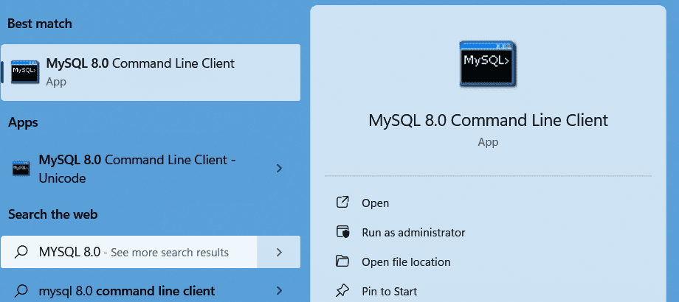
Step 2: Enter Password
After opening the client, enter the MySQL root password that was set during installation.
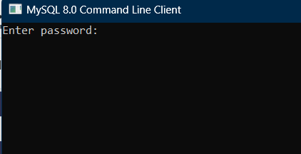
Step 3: View Existing Databases
Run the following command to see all databases currently available in the system.
SHOW DATABASES;
Output:
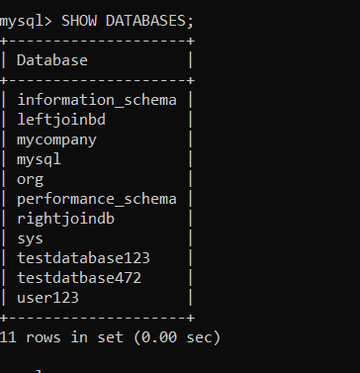All databases present in the system
Step 4: Create a New Database
Execute the following command to create a new database.
CREATE DATABASE IF NOT EXISTS DATABASE_NAME;
Output:
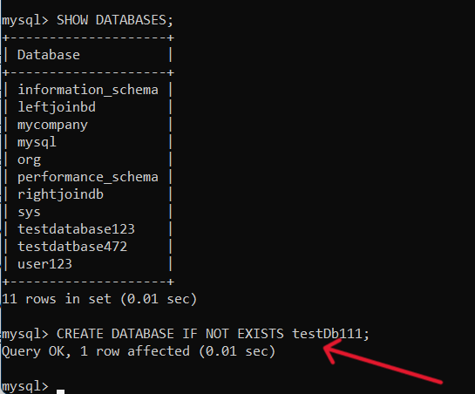
If the command runs successfully, the database will be created.
Step 5: Verify Database Creation
Run the following command again to confirm the database has been created.
SHOW DATABASES;
Output:
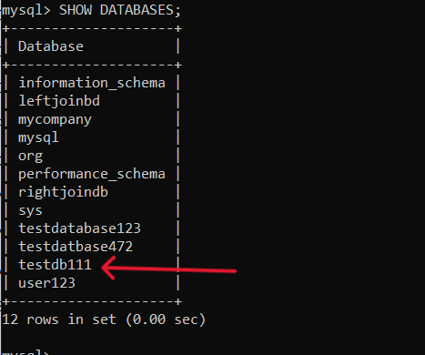
Step 6: Use the Database
To start working with the database, run the following command:
USE DATABASE_NAME;
MySQL Workbench
MySQL Workbench is a graphical tool used to design, manage, and interact with MySQL databases. It provides a Graphical User Interface (GUI) that simplifies database management compared to command-line operations.
- Allows users to visually create and manage databases, tables, and queries.
- Suitable for users who prefer a graphical interface instead of working with command-line tools.
Implementation
MySQL Workbench is a graphical tool used to design, manage, and interact with MySQL databases. You can install MySQL Workbench on your system to manage databases using a graphical interface instead of command-line tools.
To create a database through MySQL Workbench follow the below steps:
Step 1: Open MySQL Workbench
Search for MySQL Workbench in the Start menu and open the application.
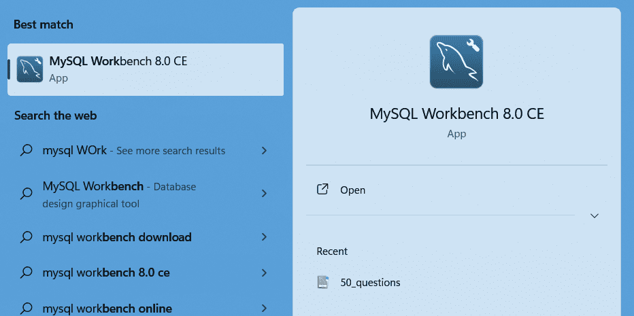
Step 2: Create a Local Connection
Click on the MySQL instance connection icon to create a new local connection.
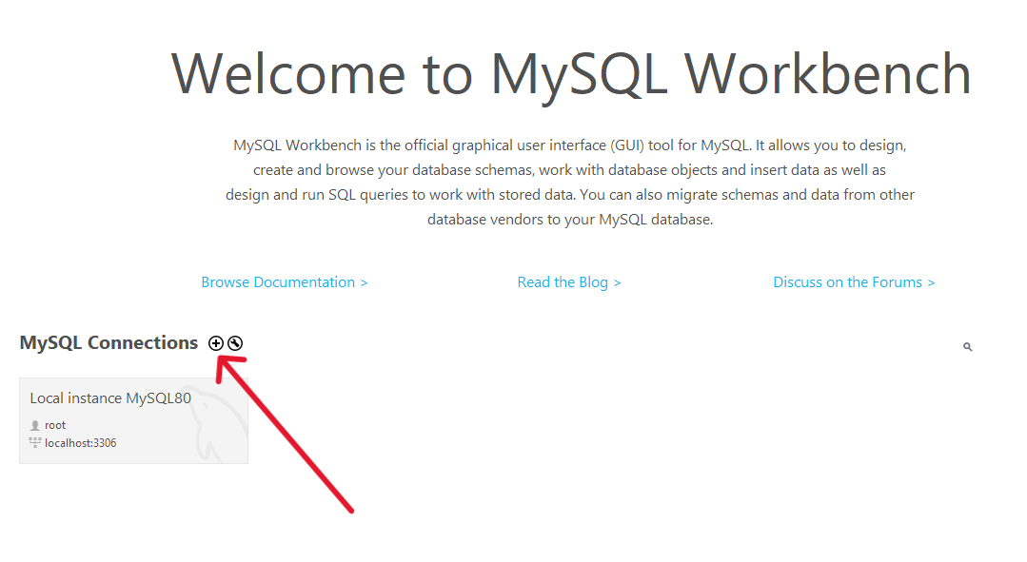
Step 3: Configure Connection
Enter Local as the connection name and click Test Connection.
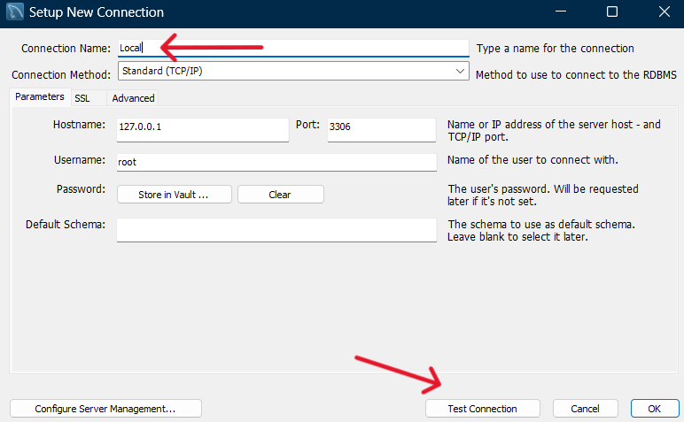
Step 4: Enter Password
Provide the MySQL password that you set during MySQL installation.
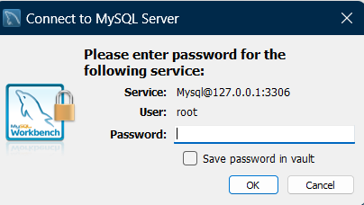
Step 5: Verify Connection
If the connection is successful, a confirmation message will appear.
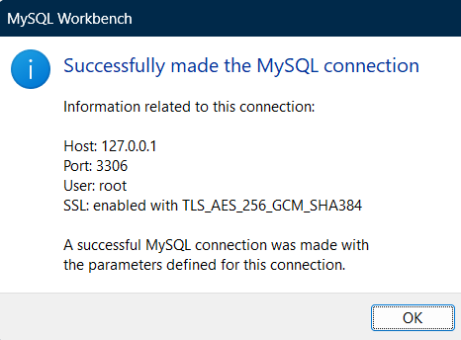
Step 6: Open the Connection
Click on the Local instance connection to open the database dashboard.
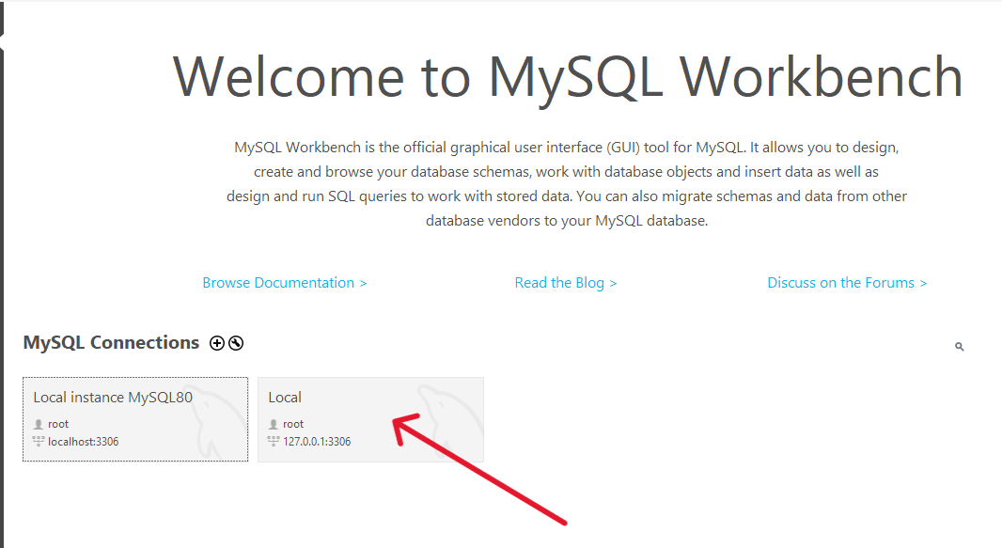
Step 7: Create Database Schema
Click the Create Schema icon in the toolbar.
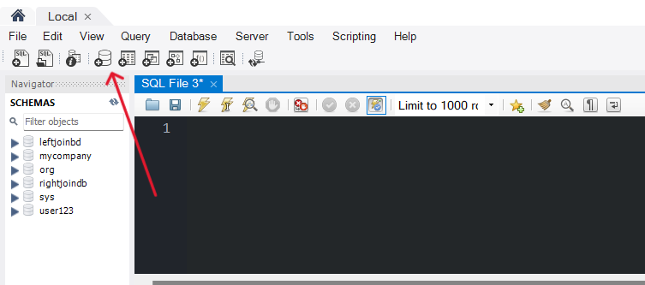
Step 8: Enter Database Details
Enter the database name and optionally select character set and collation, then click Apply.
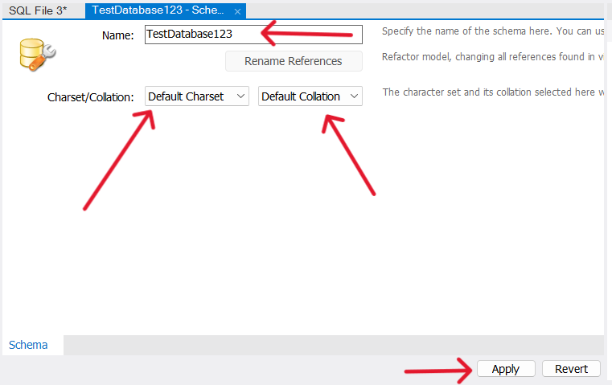
Step 9: Apply Settings
Click Apply again without changing the default settings.
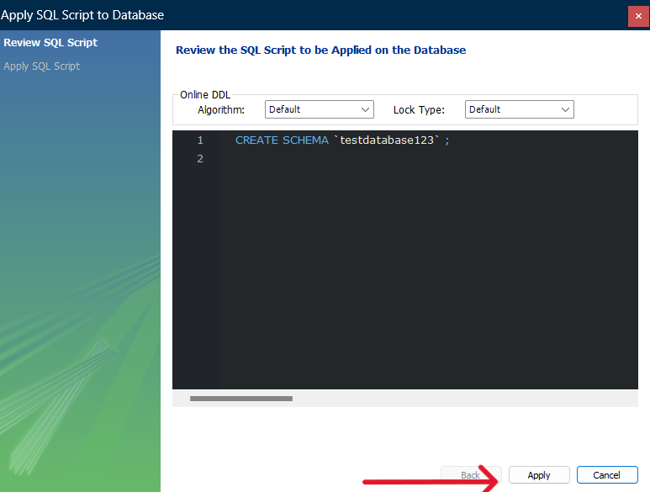
Step 10: Finish Database Creation
Click Finish to complete the database creation process.
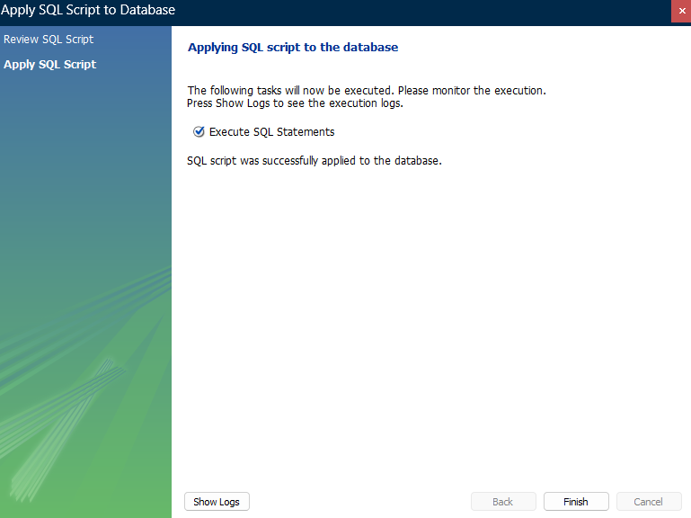
Step 11: View Created Database
You will now see the created database listed in the left-side schema panel.
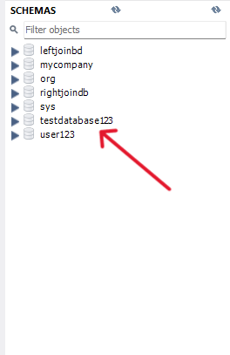
Step 12: Set Default Schema
Right-click on the database you created and click on Set, as Default Schema to use your database. Now your database is ready to use.
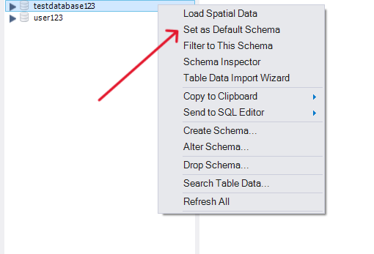

MySQL Drop Database
Last Updated : 20 Mar, 2026

The DROP DATABASE command in MySQL is used to permanently delete an entire database along with all its associated objects. It is a powerful but risky operation, as the deletion is irreversible and results in complete data loss.
- Permanently removes the database, including all tables, views, stored procedures, and data.
- Must be used with caution, as once executed, the database and its contents cannot be recovered.
Dropping a database in MySQL can be achieved through several methods. Some most important ones are given below.
1. Using MySQL Command Line Client
Using the MySQL Command Line Interface (CLI), the DROP DATABASE command is executed with the database name specified.
Syntax:
DROP DATABASE database_name;
This command permanently erases the specified database, so ensure the correct database name is used to prevent unintended deletions.
Example of DROP Database
Follow the steps below to understand how to create, view, drop, and verify the deletion of a database in MySQL.
Step 1: Create the Database using the Command Line Interface, see the below command to Creating Database Library.
Query:
CREATE DATABASE library;
Output:
Create the database
Step 2: Retrieve the List of Database to Confirm that the Database is Created Successfully.
SHOW DATABASES;
Output:
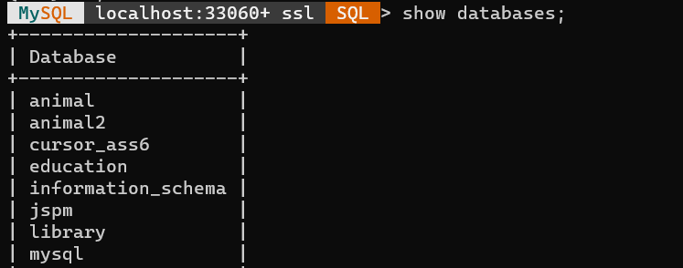
Step 3: Drop the Database library using the following Command.
DROP DATABASE library;
Output:
Step 4: Verifying that the database library is deleted successfully from the list of databases
SHOW DATABASES;
Output:
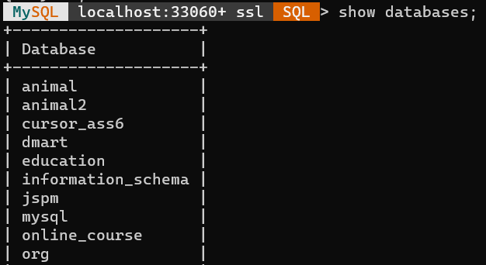
2. Using MySQL Workbench
MySQL Workbench is a visual interface for MySQL, offers an alternative method to dropping the database. Follow the below process step by step to drop the database using MySQL Workbench.
Step 1: Navigate to the SCHEMAS Section in the Sidebar.
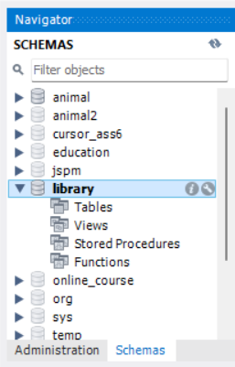
Step 2: Right Click on the Target Database and Select Drop Schema.
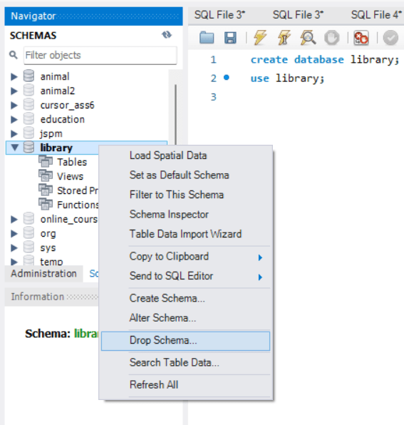
Step 3: Confirm the Deletion in the Prompt.
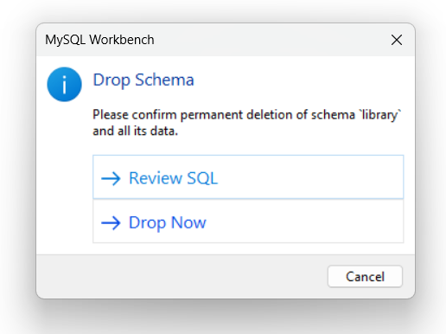
After your MySQL environment is set up, you can write your SQL program. Below is the example to display " Hello World" using SQL.
1. Create a database named test_db
CREATE DATABASE test_db;
2. Use the test_db database
USE test_db;
3. Create a table named greetings
CREATE TABLE greetings (
id INT PRIMARY KEY,
message VARCHAR(255)
);
3. Insert the message 'Hello, World!' into the greetings table
INSERT INTO greetings (id,message)
VALUES (1,'Hello, World!');
4. Retrieve the message from the greetings table
SELECT message FROM greetings;
Output:
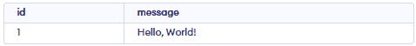
Note: Try replacing "Hello World!" with your name in the SQL query. It's a fun way to see how databases store and display your own data! Give it a try and watch your name pop up!
SQL Basics
Covers core concepts like introduction, data types, operators, commands, comments, applications and SQL career path to build a strong foundation
SQL Data Types
Last Updated : 11 Jun, 2026

In SQL, each column must be assigned a data type that defines the kind of data it can store, such as integers, dates, text or binary values. Choosing the correct data type is important for data integrity, query performance and efficient indexing.

1. Numeric Data Types
Numeric data types are used to store integer and decimal values. They support mathematical operations and are commonly used for financial, scientific and analytical data.
Exact Numeric Datatype
Exact numeric types are used when precise numeric values are needed, such as for financial data, quantities and counts. Some common exact numeric types include:
Data Type | Description | Range
BIGINT | Large integer numbers | -9,223,372,036,854,775,808 to 9,223,372,036,854,775,807
INT | Standard integer values | -2,147,483,648 to 2,147,483,647
SMALLINT | Small integers | -32,768 to 32,767
TINYINT | Very small integers | 0 to 255
DECIMAL | Exact fixed-point numbers (e.g., for financial values) | -10^38 + 1 to 10^38 - 1
NUMERIC | Similar to DECIMAL, used for precision data | -10^38 + 1 to 10^38 - 1
Example:
CREATE TABLE Product_Sales (
ProductID INT PRIMARY KEY,
Quantity SMALLINT,
UnitPrice DECIMAL(10,2),
TotalAmount DECIMAL(10,2)
);
Approximate Numeric Datatype
These types are used to store approximate values, such as scientific measurements or large ranges of data that don't need exact precision.
Data Type | Description | Range
FLOAT | Approximate numeric values | -1.79E+308 to 1.79E+308
REAL | Similar to FLOAT, but with less precision | -3.40E+38 to 3.40E+38
Example:
CREATE TABLE Measurements (
SensorID INT,
Temperature FLOAT,
Humidity REAL
);
Data Type | Description
CHAR | Stores fixed-length non-Unicode characters with a maximum length of 8000 characters
VARCHAR | Stores variable-length non-Unicode characters with a maximum length of 8000 characters
VARCHAR(MAX) | Stores variable-length non-Unicode data with a maximum size of 2³¹ − 1 characters (introduced in SQL Server 2005)
TEXT | Stores variable-length non-Unicode data with a maximum size of 2,147,483,647 characters
2. Character and String Data Types
Character data types are used to store text or character-based data. The choice between fixed-length and variable-length data types depends on the nature of your data.
Example:
CREATE TABLE Employee_Info (
EmpID INT PRIMARY KEY,
FirstName VARCHAR(50),
LastName CHAR(30),
Bio Nvarchar(max)
);
Unicode Character String Data Types
Unicode data types are used to store characters from any language, supporting a wider variety of characters. These are given in below table.
Data Type | Description
Nchar | The maximum length of 4000 characters(Fixed-Length Unicode Characters)
Nvarchar | The maximum length of 4000 characters.(Variable-Length Unicode Characters)
Nvarchar(max) | The maximum length of 2^31 - 1 characters(SQL Server 2005 only). (Variable Length Unicode data)
Example:
CREATE TABLE International_Users (
UserID INT PRIMARY KEY,
FullName NVARCHAR(100),
Country NCHAR(50)
);
3. Date and Time Data Type
SQL provides several data types for storing date and time information. They are essential for managing timestamps, events and time-based queries. These are given in the below table.
Data Type | Description | Storage Size
DATE | Stores the data of date (year, month, day) | 3 Bytes
TIME | Stores the data of time (hour, minute,second) | 3 Bytes
DATETIME | Stores both the data and time (year, month, day, hour, minute, second) | 8 Bytes
Example:
CREATE TABLE Orders (
OrderID INT PRIMARY KEY,
OrderDate DATE,
OrderTime TIME,
ShippedAt DATETIME
);
4. Binary Data Types in SQL
Binary data types are used to store binary data such as images, videos or other file types. These include
Data Type | Description | Max Length
Binary | Fixed-length binary data. | 8000 bytes
VarBinary | Variable-length binary data. | 8000 bytes
Image | Stores binary data as images. | 2,147,483,647 bytes
Example:
CREATE TABLE Product_Images (
ImageID INT PRIMARY KEY,
ImageName VARCHAR(100),
ImageData VARBINARY(MAX)
);
5. Boolean Data Type in SQL
Boolean data types store logical values such as TRUE and FALSE. In SQLite, these values are typically represented using integers. where:
- 1 represents TRUE
- 0 represents FALSE
Example:
CREATE TABLE User_Status (
UserID INT PRIMARY KEY,
IsActive INTEGER,
IsVerified INTEGER
);
6. Special Data Types
SQL also supports some specialized data types for advanced use cases:
- XML Data Type: Used to store XML data and manipulate XML structures in the database
Example:
CREATE TABLE XML_Records (
RecordID INT PRIMARY KEY,
ConfigData XML
);
- Spatial Data Type (Geometry): stores planar spatial data, such as points, lines and polygons, in a database table.
Example:
CREATE TABLE Locations (
LocationID INT PRIMARY KEY,
Area GEOMETRY
);

